4-18 Main Question (สำหรับแสดงข้อสอบ)

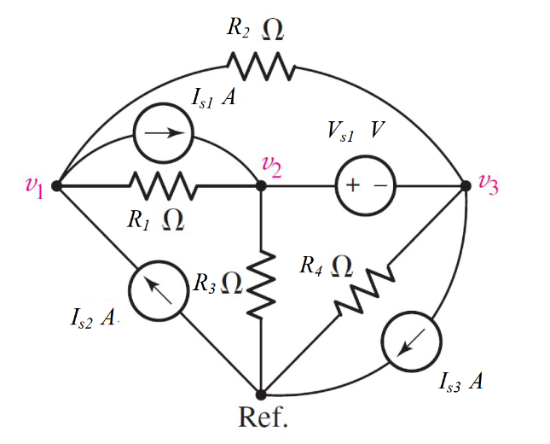

Given *I*1 = 5A, *I*2 = 3 A, *I*3 = 8 A, Vs=4 V, *R*1 = 5 Ω, *R*2 = 1 Ω, *R*3 = 3 Ω, *R*4 = 2 Ω.

Find

Variables (สำหรับเขียนโค้ดเพื่อหาคำตอบ)

Random variables

IS1 = {1:5}; IS2 = {1:5}; IS3 = {5:10}; VS = {1:5};

R1 = {1:5}; R2 = {1:5}; R3 = {1:5}; R4 = {1:5};

Global variables

#IS1 = 5; IS2 = 3; IS3 = 8; VS=4;

#R1 = 5; R2 = 1; R3 = 3; R4 = 2;

G11 = 1/R1+1/R2; G12 = -1/R1; G13 = -1/R2;

G21 = -1/R1-1/R2; G22 = 1/R1+1/R3; G23 = 1/R2+1/R4;

G31 = 0; G32 = 1; G33 = -1;

I1 = IS2-IS1; I2 =IS1-IS3; I3 = VS;

D = G11\*G22\*G33+G12\*G23\*G31+G13\*G21\*G32-G31\*G22\*G13-G32\*G23\*G11-G33\*G21\*G12;

D1 = I1\*G22\*G33+G12\*G23\*I3+G13\*I2\*G32-I3\*G22\*G13-G32\*G23\*I1-G33\*I2\*G12;

D2 = G11\*I2\*G33+I1\*G23\*G31+G13\*G21\*I3-G31\*I2\*G13-I3\*G23\*G11-G33\*G21\*I1;

D3 = G11\*G22\*I3+G12\*I2\*G31+I1\*G21\*G32-G31\*G22\*I1-G32\*I2\*G11-I3\*G21\*G12;

V1 = D1/D; V2 = D2/D; V3 = D3/D;

Part (กรอกคำตอบ)

1. *V*1 = V1 = -8.6 V
2. *V*2 = V2 = -3.6 V
3. *V*3 = V3 = -7.6 V

4-19 Main Question (สำหรับแสดงข้อสอบ)

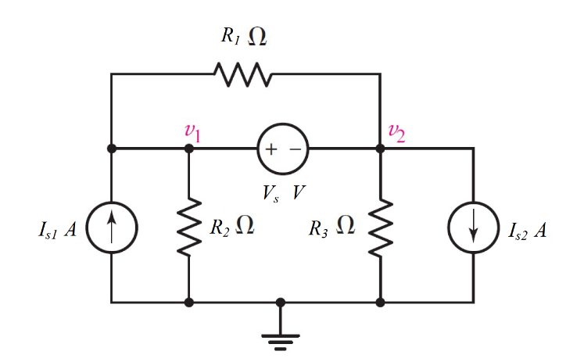

Given *I*1 = 3 A, *I*2 = 5 A, Vs=9 V*, R*1 = 1 Ω, *R*2 = 5 Ω, *R*3 = 9 Ω

Find

Variables (สำหรับเขียนโค้ดเพื่อหาคำตอบ)

Random variables

IS1 = {1:5}; IS2 = {1:5}; VS = {5:10};

R1 = {1:5}; R2 = {1:5}; R3 = {5:10};

Global variables

#IS1 = 3; IS2 = 5; VS=9; R1 = 1; R2 = 5; R3 = 9;

G11 = 1/R1+1/R2; G12 = 1/R3-1/R1; G21 = 1; G22 = -1;

I1 = IS1-IS2; I2 = VS;

D = G11\*G22-G12\*G21;

D1 = I1\*G22-I2\*G12;

D2 = G11\*I2-G21\*I1;

V1 = D1/D; V2 = D2/D;

Part (กรอกคำตอบ)

1. *V*1 = V1 = -31.4 V

2. *V*2 = V2 = -41.14 V

4-20 Main Question (สำหรับแสดงข้อสอบ)

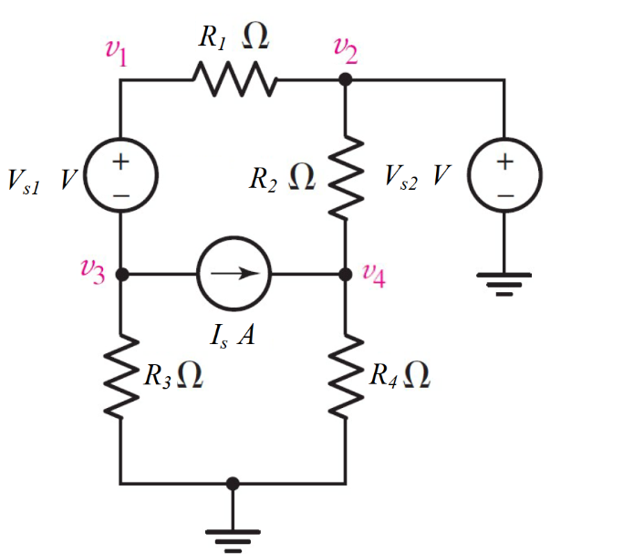

Given *V*1 = 6 V, *V*2 = 5 A, Is=2 A*,* *R*1 = 10 Ω, *R*2 = 4 Ω, *R*3 = 1 Ω, *R*4 = 2 Ω

Find

Variables (สำหรับเขียนโค้ดเพื่อหาคำตอบ)

Random variables

VS1 = {5:10}; VS2 = {5:10}; IS = {1:5};

R1 = {5:15}; R2 = {1:5}; R3 = {1:5}; R4 = {1:5};

Global variables

#VS1 = 6; VS2 = 5; IS = 2;

R1 = 10; R2 = 4; R3 = 1; R4 = 2;

G11 = 1/R1; G12 = 1/R3; G13 = 0;

G21 = 0; G22 = 0; G23 = 1/R2+1/R4;

G31 = 1; G32 = -1; G33 = 0;

V2=VS2;

I1 = V2/R1-IS; I2 =IS+V2/R2; I3 = VS1;

D = G11\*G22\*G33+G12\*G23\*G31+G13\*G21\*G32-G31\*G22\*G13-G32\*G23\*G11-G33\*G21\*G12;

D1 = I1\*G22\*G33+G12\*G23\*I3+G13\*I2\*G32-I3\*G22\*G13-G32\*G23\*I1-G33\*I2\*G12;

D2 = G11\*I2\*G33+I1\*G23\*G31+G13\*G21\*I3-G31\*I2\*G13-I3\*G23\*G11-G33\*G21\*I1;

D3 = G11\*G22\*I3+G12\*I2\*G31+I1\*G21\*G32-G31\*G22\*I1-G32\*I2\*G11-I3\*G21\*G12;

V1 = D1/D; V3 = D2/D; V4 = D3/D;

Part (กรอกคำตอบ)

1. *V*1 = V1 = 4.09 V
2. *V*2 = V2 = 5 V
3. *V*3 = V3 = -1.909 V
4. *V*4 = V4 = 4.333 V

4-23 Main Question (สำหรับแสดงข้อสอบ)

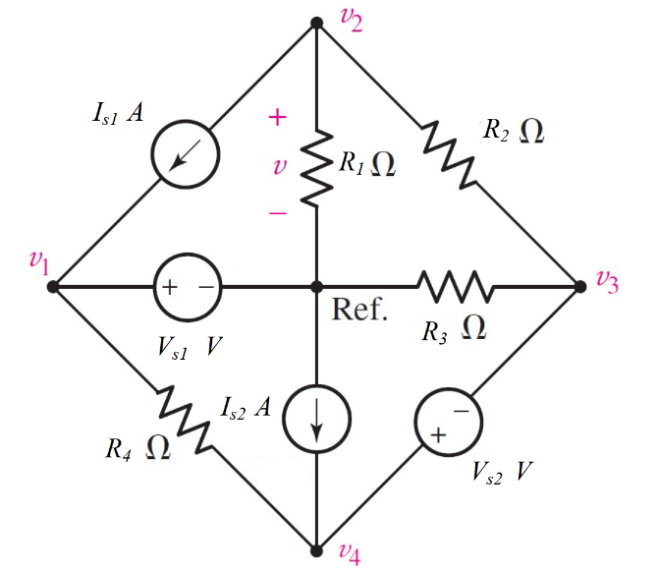

Given *Is*1 = 1 A, *Is*2 = 5 A, *Vs*1 = 5 V, *Vs*2 = 10 V, *R*1 = 2 Ω, *R*2 = 10 Ω, *R*3 = 20 Ω., *R*4 = 12 Ω.

Find

Variables (สำหรับเขียนโค้ดเพื่อหาคำตอบ)

Random variables

IS1 = {1:10}; IS2 = {1:10}; VS1 = {5:10}; VS2 = {5:10};

R1 = {1:5}; R2 = {5:10}; R3 = {10:20}; R4 = {10:20};

Global variables

#IS1 =1; IS2 = 5; VS1 = 5; VS2 = 10;

R1 = 2; R2 = 10; R3 = 20; R4 = 12;

G11 = 1/R1+1/R2; G12 = -1/R2; G13 = 0;

G21 = -1/R2; G22 = 1/R2+1/R3; G23 = 1/R4;

G31 = 0; G32 = -1; G33 =1;

V1=VS1;

I1 = -IS1; I2 =IS2+V1/R4; I3 = VS2;

D = G11\*G22\*G33+G12\*G23\*G31+G13\*G21\*G32-G31\*G22\*G13-G32\*G23\*G11-G33\*G21\*G12;

D1 = I1\*G22\*G33+G12\*G23\*I3+G13\*I2\*G32-I3\*G22\*G13-G32\*G23\*I1-G33\*I2\*G12;

D2 = G11\*I2\*G33+I1\*G23\*G31+G13\*G21\*I3-G31\*I2\*G13-I3\*G23\*G11-G33\*G21\*I1;

D3 = G11\*G22\*I3+G12\*I2\*G31+I1\*G21\*G32-G31\*G22\*I1-G32\*I2\*G11-I3\*G21\*G12;

V2 = D1/D; V3 = D2/D; V4 = D3/D;

Part (กรอกคำตอบ)

1. *V*1 = V1 = 5 V
2. *V*2 = V2 = 1.73 V
3. *V*3 = V3 = 20.38 V
4. *V*4 = V4 = 30.38 V

4.24 Main Question (สำหรับแสดงข้อสอบ)

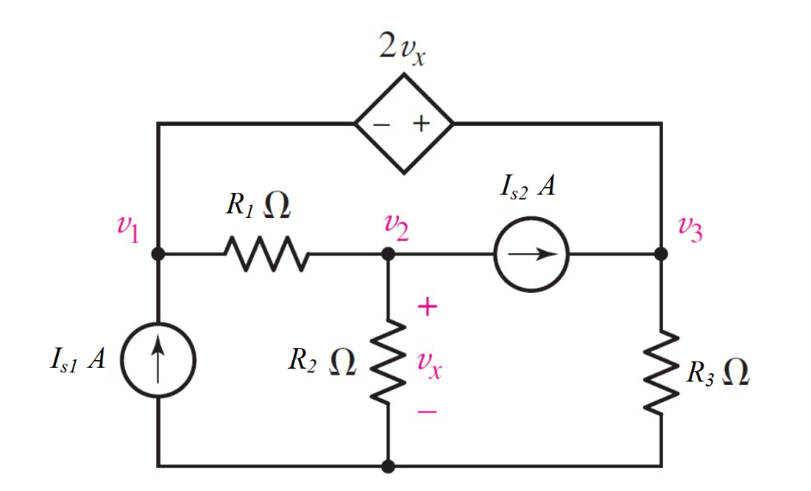

Given *I*1 = 1 A, *I*2 = 8 A, *R*1 = 5 Ω, *R*2 = 3 Ω, *R*3 = 2 Ω,

Find

Variables (สำหรับเขียนโค้ดเพื่อหาคำตอบ)

Random variables

IS1 = {1:5}; IS2 = {5:10};

R1 = {1:5}; R2 = {1:5}; R3 = {1:5};

Global variables

#IS1 =1; IS2 = 8;

R1 = 8; R2 = 5; R3 = 2;

G11 = 1/R1; G12 = -1/R1; G13 = 1/R3;

G21 = -1/R1; G22 = 1/R1+1/R2; G23 = 0;

G31 = -1; G32 = -2; G33 =1;

I1 = IS1+IS2; I2 =-IS2; I3 = 0;

D = G11\*G22\*G33+G12\*G23\*G31+G13\*G21\*G32-G31\*G22\*G13-G32\*G23\*G11-G33\*G21\*G12;

D1 = I1\*G22\*G33+G12\*G23\*I3+G13\*I2\*G32-I3\*G22\*G13-G32\*G23\*I1-G33\*I2\*G12;

D2 = G11\*I2\*G33+I1\*G23\*G31+G13\*G21\*I3-G31\*I2\*G13-I3\*G23\*G11-G33\*G21\*I1;

D3 = G11\*G22\*I3+G12\*I2\*G31+I1\*G21\*G32-G31\*G22\*I1-G32\*I2\*G11-I3\*G21\*G12;

V1 = D1/D; V2 = D2/D; V3 = D3/D;

Part (กรอกคำตอบ)

1. *V*1 = V1 = 31.76 V
2. *V*2 = V2 = -12.4V
3. *V*3 = V3 = 6.69 V